ASU Faculty Senate Finance Committee Report 2009
Presented: February 20, 2009

Committee Members: Richard Freer, Mike Hall, Louella Moore (Primary Data Analysis), William Rowe, Richard Segall, Ahmad Syamil, Johnny VanHorn

The Faculty Senate Finance Committee studies long term spending trends for Arkansas State University with emphasis on the Jonesboro campus. The committee views this report as a digest of key trends of interest to faculty and other constituents and is presented as a service to ASU and to Arkansas taxpayers. The committee does not compile statistical or accounting data directly, but makes use of publicly available reports such as reports prepared by the Office of Institutional Research along with public sources of information provided by the Southern Regional Educational Board (SREB), the Arkansas Department of Higher Education (ADHE), and the Arkansas Division of Legislative Audit on their respective websites. This report is organized as follows: 1) Economic environment, 2) General financial condition of ASU, 3) Trends in faculty composition and qualifications, 4) Relative staffing changes between faculty and other categories, 5) Instructional Spending, 6) Tuition and enrollment trends, 7) Athletics and Auxiliary trends, and 8) Other concerns.

Section 1. Economic Environment

Weaknesses in the current US and global economy impact financing available for state and federal appropriations to colleges and universities. The current Arkansas governor is committed to decreasing the sales tax on groceries even when it means cutting appropriations to state agencies. This was evidenced by cuts in expected university funding for fiscal year 2008-09 even prior to actual decreases in sales tax collections. These cuts resulted in faculty and staff receiving a meager 2% raise, well below the cost of inflation, coupled with increases in health care costs that in some cases exceeded the raises received. While the Arkansas legislators voted themselves a cost of living increase in excess of 3% early in the 2009 session, it is not yet clear whether funds will be available for a similar increase to other public employees.

Though faculty and staff have received only meager raises in the last decade, the public perceives the cost of a college education as too high. The public is increasingly impatient with state wide tuition increases that have hovered around 8% per year for the last decade. Some of these increases have been necessary due to restrictions on state level appropriations and a need to keep up with ever advancing technology. In other words, tuition rates are higher, but students also have access to a much higher level of technological services than they did a decade ago. For their tuition dollars, students also have access to a wider array of remedial and tutorial services than a decade ago. In the case of Arkansas State University, some increase might also be attributed to choices to fund a dedicated systems office, to add upper level administrative staff, and to increase research output even though these are not elements which would provide additional funding under current state appropriations formulas.

Section 2. General Financial Condition of the University

Illustration 1 shows traditional ratios that measure the liquidity and fund balance of ASU compared to other large public 4 year institutions in Arkansas as computed from the audited financial statements for the year indicated. A rule of thumb is that a current ratio of 2 to 1 provides an adequate cushion of current assets (generally cash and receivables) to cover known liabilities coming due within the next year. ASU-Jonesboro (ASUJ) and the ASU System (ASUS) as whole meet this criterion, though UCA was well below this level as of June 30, 2007. Another rule of thumb is that an organization would like to have a cushion of at least 10% in its unrestricted assets. ASUJ was barely at this level (10.68%) in 2008 which was improved slightly from the prior year’s level of 8.32%. Restricted but expendable net assets primarily include fund balances restricted to certain departments and programs. If these are included the cushion is 14.33%. Comparison figures are available in Illustration 1A for other schools.

As part of the Finance Committee’s analysis, we noted that audited financial statements include three types of scholarships with different accounting treatments. One type is netted from the gross tuition at the top of the financial statements as an ‘allowance’. Another type is shown as an operating expense. Reports in the media have noted that the legislature has imposed a 30% cap for scholarships and is considering a 15% cap. Media reports have noted that some schools in Arkansas are over 30% while ASUJ is near the 15% mark. Our analysis in Illustration 1B found that if both types of tuition reductions are considered, ASUJ actually reduces gross fees charged by at least 55% which appears to be slightly higher or roughly equivalent to the comparison group schools. These figures do not include the value of reduced tuition rates for employees and dependents which are not reported separately on the financial statements but are aggregated within personal services and salaries. The implications are that for each $100 increase in tuition and fees, on average, the institution nets less than $45, but with the effect on individual students being uneven. Students who do not qualify for either scholarships or Pell grants will bear the full $100 increase. Illustration 1B net tuition provides approximately 15% of the funds to pay basic operating expenses while state appropriations make up 46% or roughly three times that amount. Together tuition and state appropriations make up 61% of the funding for operating expenses. The remaining 39% comes from interest, auxiliary profits, as well as grants and contracts including Pell grant revenue.

Illustration 2 summarizes the information from the respective Statements of Cash Flow. Cash Flows are divided into Operating, Financing, and Investing flows. Illustration 2 indicates how much each school’s cash operating deficit would have been just based on tuition and other revenues without state appropriations, cash received from state appropriations, and how the net funds available after state appropriations were used – whether for capital financing or for investment purposes. Illustration 2 indicates that the ASU System generated $23.6 from basic operations and reinvested $23.7 in capital assets. The decrease in net cash flow of approximately $882,000 does not indicate fiscal stress because 1) the systems has adequate liquidity ratios as reported above, and 2) the reduction is essentially the net amount of new investments purchased over investment income.

Illustration 3 shows information on the relative size of the interest and principal payments. In 2008 ASUJ had several financing projects under way. Interest on those projects is capitalized in the cost of the projects until they are completed. However, interest is building up on those projects in addition to actual interest paid. For many of the projects under construction, additional revenues from rents received may more than cover the interest payments after the projects are open for use. The illustration shows that if that capitalized interest were added to actual interest payments, the interest burden would have been much higher. While these calculations are extra conservative because the revenues to match the interest expenses are not yet accruing, the calculation serves to emphasize that while current interest payments are reasonable in relation to comparison schools, additional construction bears watching. If interest and principal payments were to increase to the level of the comparison schools they would pose a significant burden on operating income as is the case for other schools in Illustration 3.

Illustration 4 shows the actual and projected cost to run the ASU Systems Office from FY2005-06 to FY2008-09 as presented on the ASU System website. In 2005-06 Compressed Video Costs were being treated as system-wide costs but have since been moved from system wide to campus budgets for accounting purposes. Illustration 4 has adjusted the raw data presented by the Systems Office website by removing the 2005-06 Compressed Video Costs to make the year by year changes more comparable. Illustration 4 shows that if the year 2005-06 is used as a base, the Systems Office Costs have increased by more than 95% in just four years for an average of 24%. If FY2006-07 is used as a base, the increase over three years has been 19.7% or an average of 6.6%. This is still well over three times the rate of increase for faculty and staff raises in 2008-09

Illustration 1A
Basic Financial Ratios
General Condition: | ASUS 08 | ASUS 07 | UCA 07 | UAS 08 | UAS 07 | UALR 08 | UAF 08
Current Ratio -- Current Assets/Current Liabilities | 2.48 | 2.34 | 0.50 | 2.65 | 2.40 | 5.60 | 2.02
Unrestricted as % of Total Assets | 10.68% | 8.32% | -1.73% | 12.49% | 12.07% | 12.25% | 7.55%
Unrestricted & Expendable Restricted as % of Total Assets | 14.33% | 10.84% | -1.73% | 19.68% | 18.54% | 22.28% | 13.72%
Total Scholarship Expense & Allowances as % Gross Tuition | 55.21% | 54.70% | 53.07% | 47.91% | 47.19% | NA | NA
Scholarship & Fellowship 'Expense' as % of Total Tuition | 15.67% | 15.30% | 30.60% | 20.17% | 20.33% | NA | NA

Illustration 1B
Scholarship and State Appropriation Detail

 | ASUS 08 | ASUS 07 | UCA 07 | UAS 08 | UAS 07 | UALR 08 | UAF 08
Net tuition less scholarships/% Oper Expense less Scholarships | 15.28% | 15.32% | 21.93% | 6.76% | 6.67% | 21.16% | 12.36%
State Appropriations as % Op. Expense less scholarships | 46.11% | 45.65% | 38.78% | 21.58% | 21.85% | 45.79% | 35.88%
Total % of Budget from Net Tuition & State Funding | 61.40% | 60.97% | 60.71% | 28.34% | 28.52% | 66.95% | 48.25%
State Appropriations /Tuition net of all scholarships | 3.02 | 2.98 | 1.77 | 3.19 | 3.28 | 2.16 | 2.90

Illustration 2
Cash Flows in Thousands
CASH FLOW: | ASUS 08 | ASUS 07 | UCA 07 | UAS 08 | UAS 07 | UALR 08 | UAF 08
Cash flow before State Approp. & Other Sources | $ (88,974) | $(74,227) | $(47,421) | $(405,265) | $(417,716) | $(69,251) | $(211,458)
State Appropriations & Other Operating Sources | 112,549 | 86,582 | 54,643 | 589,382 | 536,430 | 82,817 | 282,072
NET FLOW FROM OPERATIONS | $ 23,575 | $ 12,355 | $ 7,221 | $184,118 | $ 118,715 | $ 13,567 | $ 70,614
CAPITAL FINANCING (Asset Purchases/Debt Paid) | -23,710 | -35,111 | -9,935 | -212,897 | -254,121 | -9,638 | -61,341
Net Sales/(Purchases) of Investments | -2,400 | 23,162 | 1,726 | 79,250 | 140,558 | -899 | 2,600
Investment Income | 1,643 | 2,645 | 405 | 10,621 | 17,050 | 2,387 | 2,718
NET CASH INCREASE OR DECREASE FOR THE YR | $ (882) | $ 3,051 | $ (582) | $ 61,092 | $ 22,202 | $ 5,417 | $ 14,591

Illustration 3
Financing – Details of Interest and Principal

Debt Ratios: | ASUS 08 | ASUS 07 | UCA 07 | UAS 08 | UAS 07 | UALR 08 | UAF 08
Total Int. Exp & Capital. % of Net Cash Flow from Oper. | 40.72% | 76.29% | 53.36% | 14.96% | 23.53% | 15.74% | 15.96%
Capital Int. Paid as % of Net Cash Flow from Operations | 6.63% | 13.18% | NA | 20.16% | 29.46% | 15.83% | 21.92%
Capital Interest & Principal Paid as % of Cash Flow from Operations | 11.79% | 23.03% | NA | 24.42% | 62.65% | 63.10% | 38.94%
Capital Interest & Principal Paid as % of Net Tuition | 10.53% | 11.86% | NA | 44.64% | 44.43% | 18.26% | 31.72%

Illustration 4
Systems Office Costs

SYSTEMS OFFICE: | 2005-06 | 2006-07 | 2007-08 | 2008-09
Total Administrative Expense | 1,574,637 | 2,111,326 | 2,388,100 | 2,527,889
Compressed Video Costs Included Above | 280,011 | 0 | 0 | 0
Net Administrative Cost w/out Compressed Video | 1,294,626 | 2,111,326 | 2,388,100 | 2,527,889
Increase From Prior Year |  | 63.1% | 13.1% | 5.9%
Increase from 2005-06 to 2008-09 |  |  |  | 95.3% | 4 yr aver. | 23.8%
Increase from 2006-07 to 2008-09 |  |  |  | 19.7% | 3 yr aver. | 6.6%

Illustration 5 shows the ASU Foundation total assets have only increased by 1%. Unrestricted balances as a percent of total assets have increased to 5%, which is still at a very modest level. Temporarily restricted balances (which include gifts designated to departments and programs) as well as the permanently restricted assets have declined.

Illustration 5
ASU Foundation Balances and Percentages

 | 2,008 | 2,007 | % Change
Total Assets | 42,547,728 | 42,127,538 | 1.00%
Unrestricted Net Assets | 2,163,446 | 178,157 | 1114.35%
Temporarily Restricted Net Assets | 6,832,478 | 7,896,739 | -13.48%
Permanently Restricted Net Assets | 32,342,698 | 33,213,233 | -2.62%
Unrestricted as % Total Assets | 5.1% | 0.4% | -----
Temporarily Restricted as % Total Assets | 16.1% | 18.7% | -----
Permanently Restrict as % Total Assets | 76.0% | 78.9% | -----

Section 3. Faculty Composition and Qualifications

In an increasingly complex world, the best jobs go to those with the ability to handle advanced analytical tasks. If students are to be adequately prepared to compete in a high tech, global environment, it is important that they be trained by faculty with credentials indicative of extensive preparation in the subject matter for the assigned teaching area. It is troubling that as of 2006, 53% of the total instructional staff for public 4-year colleges in SREB states were made up of part time faculty and teaching assistants. In 2 year public schools for the same time period, part time and teaching assistants made up 68% of the faculty.

Illustration 6 shows the trends in full time vs. part time faculty for ASUJ. Illustration 7 shows the level of qualifications for the full time faculty in 2002, 2006, and 2008 with 1993 used to provide a base for the long term trend. The % of ASUJ’s doctorally qualified full time faculty has remained roughly constant with approximately 73% of faculty being full time and 27% part time, however this is somewhat understated as data on the number of classes taught by teaching assistants was not readily available. It should also be noted that this chart does not include teaching assistants or courses taught by faculty in high school concurrent enrollment courses. If these were included the ratio of full time to part time faculty would have been lower. While Illustration 6 seems to indicate that the level of full time to part time faculty, excluding TA’s and concurrent enrollment faculty, has held roughly steady, the results may have been closer to the SREB averages if data on TA’s and concurrent enrollment had been more readily available.
Illustration 6
Full Time vs. Part Time Faculty (Excluding TA’s)

 | Fall 2002 |  | Fall 2006 |  | Fall 2008
Full Time | 446 | 72.60% | 456 | 73.70% | 461 | 73.2%
Part Time | 168 | 27.40% | 163 | 26.30% | 169 | 26.8%
TOTAL | 614 | 100.00% | 619 | 100.00% | 630 | 100.0%

Illustration 7
Full Time Faculty Qualifications Over Time

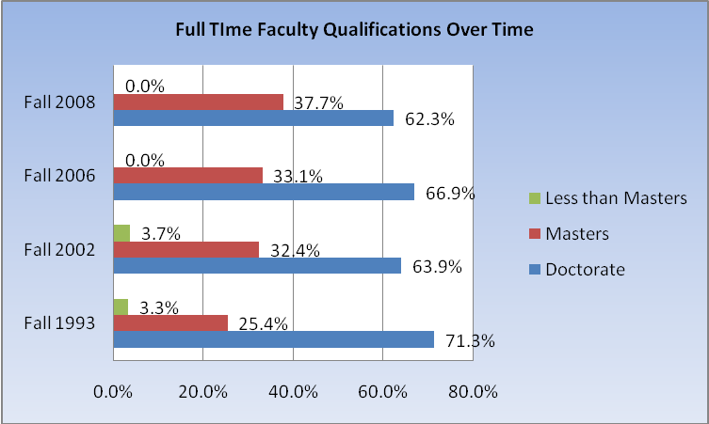
 | Fall 1993 |  | Fall 2002 |  | Fall 2006 |  | Fall 2008
Doctorate | 281 | 71.3% | 276 | 63.9% | 305 | 66.9% | 287 | 62.3%
Masters | 100 | 25.4% | 140 | 32.4% | 151 | 33.1% | 174 | 37.7%
Less than Masters | 13 | 3.3% | 16 | 3.7% | 0 | 0.0% | 0 | 0.0%
 | 394 | 100.0% | 432 | 100.0% | 456 | 100.0% | 461 | 100.0%
Illustration 7 shows the number of persons with doctoral or other terminal degrees compared to those with masters degrees over time. While the number of persons with doctorate degrees increased slightly from 2002 to 2006 but decreased again in 2008; the long term trend seems to be that the level of doctorally qualified faculty is decreasing. The committee notes that this is especially troubling given the trend toward more students taking freshman and sophomore courses at junior colleges. With the increased emphasis on the ASUJ campus on upper level and graduate coursework along with its goal of becoming more research oriented, one would expect that the faculty credentials should be greater, not lower, than those in 1993. Illustration 8 emphasizes that most part time faculty do not have credentials beyond a master’s degree.

Illustration 8
Part Time Faculty Credentials

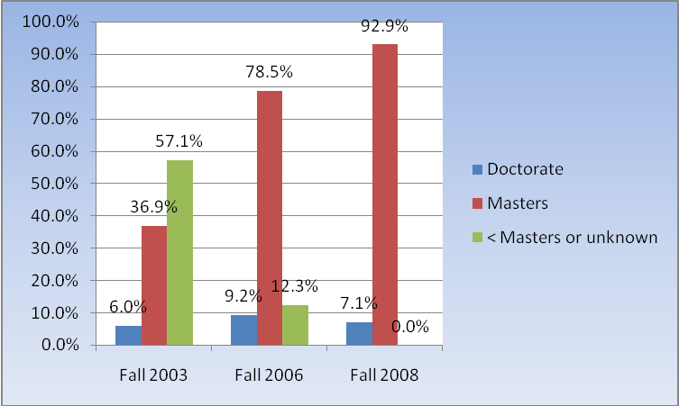

Illustration 9 shows the number of tenured faculty has declined from 43.4% to 35.2% in just four years; tenure track replacements have been hired but at a lower rate than the reduction in tenured faculty who are retiring or otherwise relocating.

Illustration 9
Changes in Tenure Track Status Over Time

 | Fall 2004 |  | Fall 2006 |  | Fall 2008
Tenured | 197 | 43.4% | 177 | 38.8% | 166 | 35.2%
Tenure track | 121 | 26.7% | 131 | 28.7% | 153 | 32.5%
Non-tenure track | 136 | 30.0% | 148 | 32.5% | 152 | 32.3%
 | 454 | 100.0% | 456 | 100.0% | 471 | 100.0%

Section 4. Relative Staffing Changes

Illustration 10 shows the trend in the number of faculty compared to other employment categories. Full time faculty have remained at relatively one third of the total employees since the base year of 1994. Craft and Maintenance workers have been roughly constant in total numbers, but have declined on a relative basis. The percentage of employees in the Administrative and Professional Category has more than doubled in total and as a percentage since the base year of 1994. Some may be due to upgrades of staff from clerical/technical, but the total number of Administrative, Professional, Clerical & Technical workers has also increased as shown in the subtotal at the bottom of Illustration 10. The graphic highlights the gradual decrease in relative faculty numbers over time and the marked increase in administrative and professional positions.

Illustration 10
Employees by Category Over Time
.
 | 1994 |  | 2002 |  | 2006 |  | 2008
Full Time Faculty | 394 | 34.8% | 432 | 33.1% | 456 | 33.3% | 461 | 32.3%
Admin./Professional | 142 | 12.6% | 313 | 23.9% | 396 | 28.9% | 439 | 30.8%
Clerical/Technical | 305 | 27.0% | 287 | 22.0% | 244 | 17.8% | 251 | 17.6%
Craft/Maintenance | 290 | 25.6% | 275 | 21.0% | 274 | 20.0% | 275 | 19.3%
TOTAL EMPLOYEES | 1131 | 100.0% | 1307 | 100.0% | 1370 | 100.0% | 1,426 | 100.0%
Total Admin & Clerical | 447 | 39.5% | 600 | 45.9% | 640 | 46.7% | 690 | 48.4%

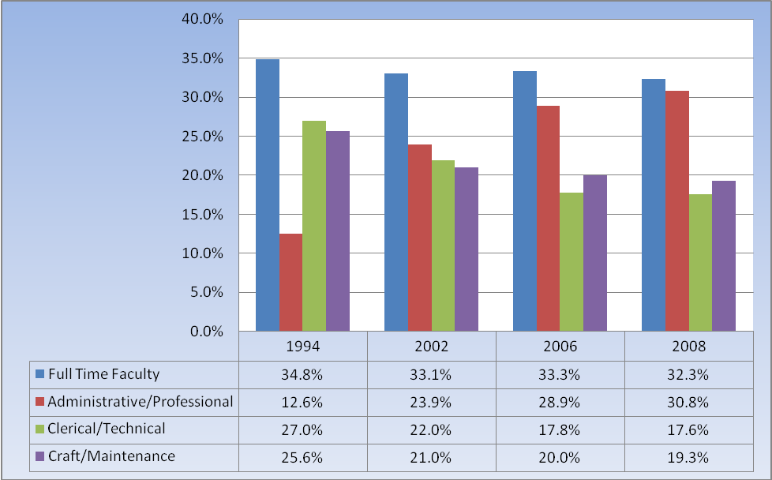

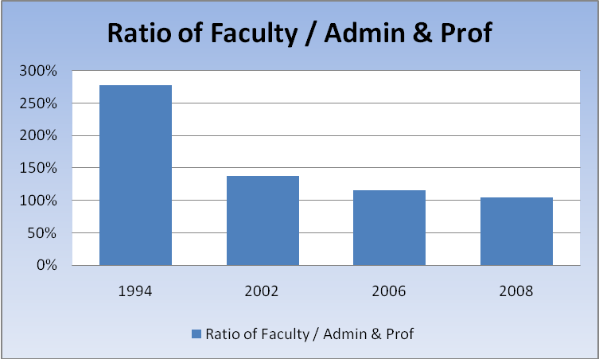
Section 5. Instructional Spending

The SREB reports that faculty salary growth trails that of the average American worker. The average wage for all workers in 2006 was $38,000 which was a 36% increased over wages in 1976 adjusted for inflation. The average wage for public four year college faculty in the U.S as a whole was $69,800 but this represented only a 10% increase in real wages adjusted for inflation compared to wages in 1976. The average wage increase adjusted for inflation for public four year colleges in the SREB states was 15% from 1976 to 2006, but the average salary of $66,000 was still $3,800 below the average overall U.S. wage in four year public colleges. Salaries in public four year colleges in the SREB states were at 95% of overall U.S. faculty compensation levels at the end of 2006 compared to 93% in 1996. On the other hand, public two-year colleges’ faculty salaries in the SREB regional dropped from 87% to 85% of national levels. From 1996 to 2006 Arkansas average salaries for public four year colleges and universities stood at an average of $56,600 which was at 80% of the national and 86% of the SREB level of average faculty salaries. In the decade from 1996 to 2006, inflation adjusted 4-year public salaries in Arkansas increased 6% compared to 7% nationwide and a 9% average for all SREB states. The SREB Fact Book 2007 notes that average base salaries for administrators at public four-year colleges in SREB states surpassed the national averages in the categories for chancellor/president (SREB average of $244,800; $17,900 more than national) and for chief academic officers (SREB average of $173,600; $2,900 above national) and chief business officers (SREB average of $152,000; $3,000 above national).

Illustration 11 compares salary levels for ASUJ full time faculty at various ranks to SREB and other Arkansas institutions in the SREB III category. This shows that Arkansas salaries have not kept up with National or SREB Salaries. Further, ASUJ salaries are thousands of dollars below those of UALR at all ranks and are behind UCA salaries at the Professor and Instructor levels. Illustrations 12A, B & C show that while ASUJ salaries generally lag those of similar regional and state level institutions, the productivity of the faculty has increased.

Illustration 11
Comparison of ASU Salaries to SREB and Others 2007-08

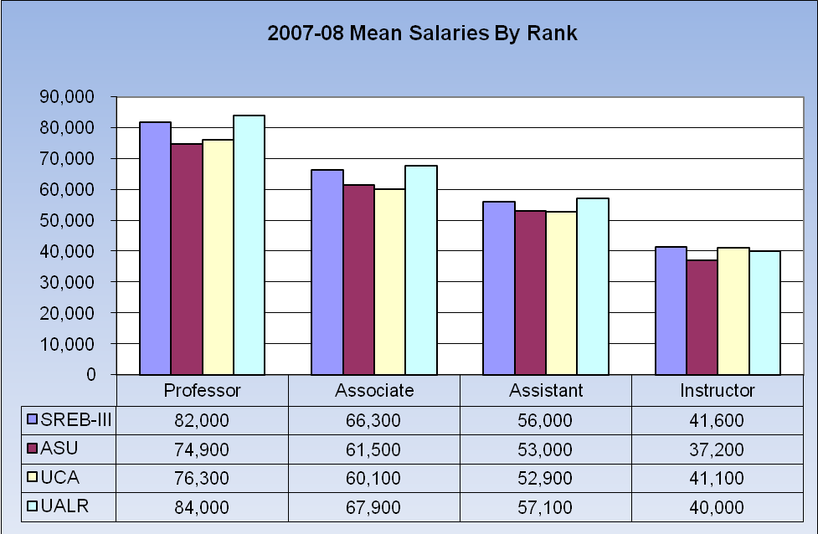
 | Professor | Associate | Assistant | Instructor
SREB-III | 82,000 | 66,300 | 56,000 | 41,600
ASU | 74,900 | 61,500 | 53,000 | 37,200
UCA | 76,300 | 60,100 | 52,900 | 41,100
UALR | 84,000 | 67,900 | 57,100 | 40,000

Illustration 12A
Increase in Credit Hours

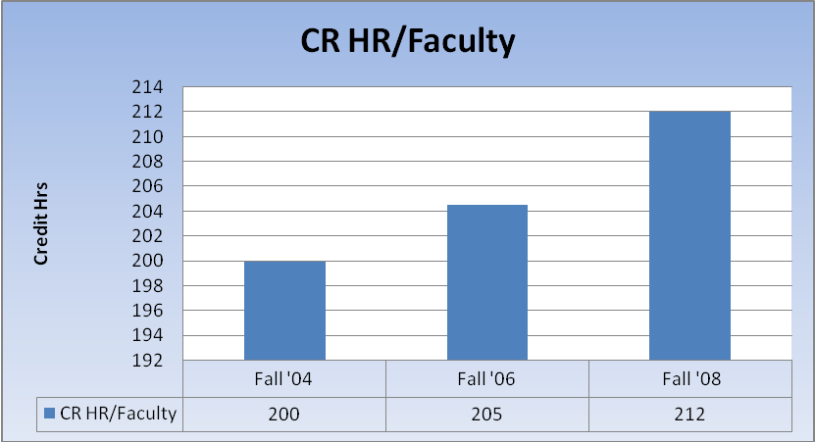

Illustration 12B
Average Credit Hours per Faculty

Illustration 12C
% Increase in Productivity

Credit hour production is only one aspect of the ways in which faculty productivity has increased in recent years. Illustration 12D shows that in spite of this demonstrable increase in productivity by faculty, raises for the last six years have generally either barely kept up with inflation or in most years have been below the % increase in the Consumer Price Index (CPI).

Prior year Faculty Senate Finance reports have noted that the percentage of the budget spent on faculty salaries and departmental operating expense tends to be among the lowest for Arkansas public institutions. Illustration 13 shows that the % of total Unrestricted Educational and General (E&G) funding dedicated to instructional salaries has continued to deteriorate in the last three fiscal years. Prior year comparison to other institutions is included in the appendix to this report. Illustration 14 shows that the

Illustration 12D
Comparison of % Raises in Comparison to CPI
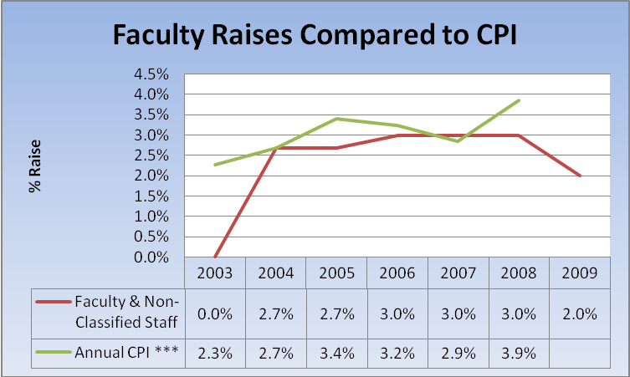

Illustration 13
Instructional Salaries as % of E&G
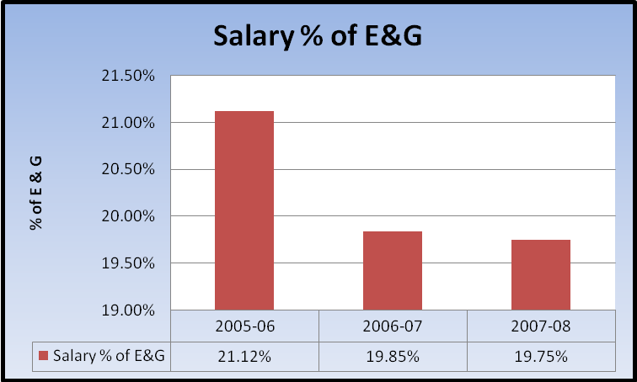

percentage of the E&G Revenues dedicated to departmental operating expenses increased slightly in 2006-07 then declined again in 2007-08.

Illustration 14
Departmental Operating Expense as % of E&G

Section 6. Tuition and Enrollment

Illustration 15 shows tuition levels for fiscal years 2004-05 and 2008-09 for the six largest public universities in Arkansas as reported on the ADHE website on p. 78 of the ASU Factbook. Illustration 15 shows that with the exception of HSU and UCA, tuition and mandatory fees for most public 4-year institutions have increased at a rate under 5% which is improved from the 10-year average of 8%.

Illustration 15
Tuition and Mandatory Fees FY2005-09

Undergraduate: | FY 04-05 | FY 08-09 | 5 yr % Change | Avg/yr
UAF | 5135 | 6399 | 24.6 % | 4.9%
ASUJ | 5155 | 6370 | 23.6 % | 4.7%
UALR | 4957 | 6121 | 23.5 % | 4.7%
UCA | 5053 | 6505 | 28.7 % | 5.7%
ATU | 4468 | 5430 | 21.5 % | 4.3%
HSU | 4168 | 6024 | 44.5 % | 8.9%

Illustration 16 shows changes in total full time equivalents (FTE) for the 5 largest public Arkansas colleges for the five year period from fiscal year 2004 through 2008. The percentage growth in FTE’s for ASUJ was 6.3% compared to a high of 21.3% for UCA and a low of 3.1% at HSU.

Illustration 17 shows more details for the breakdown between undergraduate and graduate FTEs for the same time period. This more detailed breakdown indicates that UCA, UAF, and ATU enrollment was up significantly at the undergraduate level while the ASUJ and UALR gains were very modest. HSU enrollment was down slightly at the undergraduate level even though they had significant increases at the graduate level.

Illustration 16
Change in Total FTE from FY 2004 to 2008
 | HC 03/04 | HC 07/08 | DIFF | %Change
UAF | 14997 | 16855 | 1858 | 12.4%
ASUJ | 9154 | 9727 | 573 | 6.3%
UALR | 8936 | 9222 | 286 | 3.2%
UCA | 9233 | 11203 | 1970 | 21.3%
ATU | 6110 | 6759 | 649 | 10.6%
HSU | 3304 | 3407 | 103 | 3.1%

Illustration 17
FTE Changes from FY 04 to 08
UAF | FTE O3/04 | FTE 07/08 | Diff. | % Change
Undergraduate | 12345 | 13974 | 1929 | 15.6%
Graduate | 2652 | 2882 | 230 | 8.7%
ASUJ
Undergraduate | 8324 | 8617 | 293 | 3.5%
Graduate | 830 | 1109 | 279 | 33.6%
UALR
Undergraduate | 7183 | 7227 | 44 | 0.6%
Graduate | 1753 | 1995 | 242 | 13.8%
UCA
Undergraduate | 8378 | 9767 | 1389 | 16.6%
Graduate | 855 | 1436 | 581 | 68.0%
ATU
Undergraduate | 5732 | 6365 | 633 | 11.0%
Graduate | 378 | 393 | 15 | 4.0%
HSU
Undergraduate | 2994 | 2952 | -42 | -3.3%
Graduate | 311 | 454 | 143 | 46.0%

Section 7. Auxiliary and Athletics Trends

The Faculty Senate Finance Committee regularly monitors trends in auxiliary profits and athletics spending. Illustration 18 shows the level profits generated by auxiliary units for fiscal years 2006, 2007 & 2008. This table shows that net profits generated from units other than athletics was approximately $1.4 Million which was down from $2.0 Million the prior year. Illustration 19 shows athletic spending trends for the three most recent fiscal years. The total losses before funding by E&G transfers, student athletic fees, and auxiliary transfers have decreased slightly from $6.0M to $5.7M. Notably, the primary revenue increase was due to positive flows from game guarantees. Ticket revenue and foundation gifts have declined from the base year 2005-06. Travel costs are down slightly. Notably, the auxiliary profits transferred to balance the books are in excess of total auxiliary profits earned for the year. As noted in previous finance reports, this would seem to be unsustainable in the long run.

Illustration 18
Net Profits from Auxiliary Operations
 | 2007-08 | 2006-07 | 2005-06
Resident Halls | 96,319 | 504,591 | 872,157
Married Student Housing | 199,895 | 264,039 | 317,740
Faculty Housing | 70,697 | 95,945 | 111,802
Food Service | 210,848 | 247,363 | 53,277
College Union | 69,733 | 33,193 | -379,939
Bookstore | 111,922 | 203,456 | 176,982
Student Org. & Publications | 0 | 0 | -36,443
Student Health Service | 0 | 0 | -
Other Auxiliary | 664,348 | 695,268 | 542,565
TOTAL PROFIT BEFORE ATHLETICS | 1,423,762 | 2,043,855 | 1,658,141
Athletics before transfers | -3,462,974 | -3,608,946 | -3,483,557
OVERALL NET LOSS | -2,039,212 | -1,565,091 | -1,825,416

Illustration 19
Athletics Funding for FY’s 2006 to 2008

Section 8. Other Concerns

Although data is not available to show the full dollar impact, a common concern on the campus seems to be the side effects produced by signing exclusive contracts with vendors such as Sodexho and others. While the quality of the Sodexho services seem to be more than adequate, informal conversations with deans and others indicate that purchase prices for small quantities of food are not reasonable. For example, if the Faculty Senate orders coffee and cookies for approximately thirty five persons the costs will be about $35 plus $25 for delivery and a $60 up charge because it was a small order. This compares to about $20 to buy the supplies at the grocery store which will be sufficient for 3 to 4 meetings. Yet when the bill for $20 is presented for reimbursement, it will be disallowed for payment from state funds because of the exclusive contract. While existing contracts must be honored, it would seem that when new contracts are negotiated there should be exceptions when the price is not within a reasonable factor of outside prices so that state funds intended for educational and other purposes are not reallocated to auxiliary and private profits. This should also be the case for charges by internal service units such as fiscal maintenance and others.

The use of dedicated fees rather than tuition sometimes seems to pose inequities of funding in times of budget cuts. For example, while some areas of campus will receive cuts in funding from mid-year cuts in state appropriations, surpluses may exist in areas funded by fees which cannot be rededicated to needs in other areas that are just as pressing. Thus fees pose a double edge sword: they can protect the overall financing of the institution but they create challenges in equitable distribution of funds.

Prior year reports indicate concerns with the level of athletic spending, the low level of spending on instruction and faculty salaries compared to other Arkansas schools, and the uses of auxiliary profits for non-academic purposes. Updated information on other schools is not currently available. Information from the prior year report is included in the appendix for these issues to provide a historical context.

Summary of the 2009 Faculty Senate Finance Report

The committee highlights the items below as the most significant findings of their study:

- The weak economic environment poses funding challenges for the coming year.

- ASUJ faculty qualifications are deteriorating at the same time that the research and graduate mission is being stressed in strategic mission documents. This is of particular concern because graduate education and higher research goals both require a faculty with higher, not lower, levels of credentials.

- Faculty numbers have held relatively constant in spite of increased enrollments over time, while professional and administrative staff have grown substantially.

- Faculty salaries are generally not keeping pace with national, regional, or comparable state institutions.

- The percentage of E&G revenues dedicated to instructional salaries and department operating costs continued to decline when they were already quite low in comparison to other Arkansas 4 year institutions.

- The ASU System Financial Statements show that as of June 30, 2008 the institution had reasonable liquidity, debt, and unrestricted net assets ratios.

- System costs and growth in upper level administrative lines have added an additional layer of significant costs.

- The level of subsidies to athletics from E&G resources and auxiliary profits appears to be unsustainable.

- Exclusive contracts pose problems in making efficient use of state funds.

Recommendations of the 2009 Faculty Senate Finance Committee

A primary purpose of the Faculty Senate Finance Committee report is to provide factual input into campus budgeting and other administrative processes. Given the findings above, the committee recommends the following considerations in the coming budget deliberations:

- Given that faculty salaries have not kept pace at the national, regional, or state level, it is extremely important that the equity review process outlined in the Faculty Handbook be fully funded and functioning as described in that Board approved document.

- Providing funding for competitive initial faculty salary offers is needed to attract qualified candidates for new positions. Numbers of new hires are not keeping up with retirements. It would be easier to find budgetary funds for new hires if existing faculty salaries were maintained at fair levels considering market and cost of living factors. Funding the formula adjustments described in the Faculty Handbook would not only benefit existing faculty, but would ease the budgetary pressures in finding adequate funds for replacement faculty.

- Funding adequate raises to faculty and staff to recognize both cost of living and meritorious performance needs to be a first priority in the budgeting process, not a residual consideration after other funding needs are met.

- Given that upper level administrative compensation is coming under increasing legislative scrutiny, we recommend that the Board of Trustees closely scrutinize any additions to upper level administrative lines, review administrative salaries and fringe benefits such as automobiles, housing allowances, and country club memberships to determine that they are not only reasonable in the market but in relation to the salary increases for rank and file faculty and staff.

- To the maximum extent possible additions to administrative and professional staff need to be studied and funded as part of the regular budgeting process, rather than having positions added and upgraded on an ad hoc basis during the budget cycle.

- ASU Foundation balances have taken more of a hit from weaknesses in the overall economy than they have benefited from capital campaign progress to date. The faculty Senate Finance committee urges that funding for academic programs should be a high priority when seeking to increase donations to the Foundation.

- Given that some predict the weak economy is likely to be with us for an extended period, it is important to engage in a systematic process to determine basic principles and priorities for fiscal reductions other than across the board cuts in raises and increases in health care costs.

- The finance committee encourages the Academic Budget Committee, the University Planning Council, and top level administration to explore outside the box solutions such as lesser increases in pay for those at the highest salary levels until reasonable ongoing salary increases and equity adjustments have been fully funded for rank and file faculty and staff.

- The finance committee encourages the Academic Budget Committee, the University Planning Council, and top level administration to carefully consider the pros and cons of fee based increases in revenue relative to base tuition. We encourage careful review of the overall level of fees not just the amount of current fee increases.

- We encourage our top level administrators and legislative liaisons to work to promote a level playing field for scholarship funding among public colleges across the state. Currently students with scholarships and high Pell grants may have a much more reasonable cost of education than those who are funding their education with loans. Providing an affordable education for all students is difficult in the current environment of intense cross-institutional competition for scholarships where some students receive a full ride while others must borrow extensively to afford a college education.

- The institution has historically been conservative in its use of long term debt. We recommend continuing to monitor the use of long term debt so that mandatory debt service levels on building projects does not diminish the flexibility to use funds for academic and other purposes.

- We recommend upper level financial and legal advisors at the campus and system level to carefully consider the side effects of exclusive purchase agreements with outside vendors and internal service units as well. We suggest that exceptions should be written into exclusive purchase contracts to cover instances in which the size of the purchase or the differential between the exclusive and outside prices would make the cost of using the dedicated vendor unreasonable. Further, the vendor representative should not be the party denying the outside purchase.

APPENDIX A:
HISTORICAL CONTEXT FOR Academic
AND Auxiliary Spending Patterns

Appendix 1. Auxiliary & Athletics Spending Patterns

Auxiliary enterprises are nonacademic, business-like activities for which colleges and institutions charge a fee. These profit centers have the potential to provide profits which can supplement campus activities beyond the resources provided by state appropriations and tuition. Illustration 20 provides information on net inflows from 10 categories of auxiliary enterprises for the fiscal year 2005-06. These figures show that while ASU netted approximately $1.6M from other auxiliary operations, it lost approximately $3.5M on athletic activities. Although all of the largest 4 year public institutions with the exception of Fayetteville spent at least 3/4 Million dollars more than they took in, ASUJ’s net spending on athletics was more than double that of any of the other schools studied.

Illustrations 21A-C give further details on athletic spending for fiscal year 2005-06. These figures are taken from Table 6.10A from the ADHE Fact Book 2007. Illustration 21A shows that before student athletic fees, transfers from E&G, and transfers from current and prior year auxiliary profits, the net cost of ASUJ athletic programs was nearly $6 Million. This compares to an essentially break even program at UAF. Net cost at UCA was roughly $4.5M, net costs at UALR were $3.5M, $2.6M at ATU, and $2.4M at HSU. Although a prior ASU Senate Finance Committee noted that ASUJ’s athletic fees were the highest in the state during fiscal year 2002, from 2004 to 2006 UALR and UCA have exceeded ASUJ in total student athletic fees. The ASUJ operating losses in fiscal year 2005-06 were covered by $2.3M in student athletic fees, $1M in transfers from E&G, and $2.6M in transfers from auxiliary profits. An interesting observation on the UAF situation is that even in a program that is sufficiently profitable that student athletic fees are not needed, still UAF transferred in $600,000 of auxiliary profits rather than providing a subsidy to the educational mission. Illustration 21B shows how the per student impact of the excess cost of athletic programs compared to ticket sales and other revenues.

Illustration 20
Auxiliary Profits & Loss Fiscal Year 2005-06

 | ASUJ | ATU | HSU | UAF | UALR | UCA
Resident Halls | 872,157 | 187,205 | 256,262 | 3,233,299 | 504,464 | (399,715)
Married Student Housing | 317,740 | - | - | 136,509 | - | -
Faculty Housing | 111,802 | - | 1,496 | - | - | -
Food Service | 53,277 | 206,121 | 233,592 | - | 163,032 | 831,128
College Union | (379,939) | - | (42,766) | (1,224,651) | (1,520,810) | (31,624)
Bookstore | 176,982 | 46,168 | 78,171 | 84,675 | 438,990 | 179,839
Student Org. & Publications | (36,443) | (78,028) | (39,848) | 122,876 | 65,803 | -
Student Health Service | - | (137,340) | (38,750) | 152,371 | - | 885,266
Other Auxiliary | 542,565 | (12,181) | (268,052) | 638,746 | 136,310 | (241,218)
TOTAL PROFIT BEFORE ATHLETICS | 1,658,141 | 211,945 | 180,105 | 3,143,825 | (212,211) | 1,223,676
Athletics before transfers | (3,483,557) | (926,968) | (1,399,455) | 1,787,453 | (775,698) | (977,735)
Net | (1,825,416) | (715,023) | (1,219,350) | 4,931,278 | (987,909) | 245,941

Illustration 21A
Athletic Deficits and How They Were Funded Fiscal Year 2005-06

Illustration 21B
Athletic Deficits and How They Were Funded Fiscal Year 2005-06

Illustration 21B above shows that ASUJ’s E&G transfers are the same as those for HSU and just slightly more than the total dollar amount transferred by HSU, the per unit amount is higher at these school because of the lower number of students even though they are in less prestigious conferences. The illustration also shows that while ASUJ does not have the highest student fees per FTE, ASUJ far exceed the other schools in its transfers of auxiliary profits into the athletic program. The committee includes the auxiliary profit transfers as an indirect cost to students because the profits existing largely from charges to students for housing and food service. Also, transfer of these profits to athletics rather than the academic function results in being forced to either reduce academic budgets or raise tuition.

Illustration 21C
Details of Athletic Deficits and Funding

 | ASUJ | ATU | HSU | UAF | UALR | UCA
Ticket Sales | 1,406,620 | 137,689 | 17,534 | 19,032,959 | 577,154 | 330,379
Media less Game Guar/Conc | 219,083 | 17,200 | 102,601 | 12,075,031 | 275,056 | 23,577
Other Income | 1,144,502 | 15,809 | 30,183 | 4,806,332 | 565,956 | 9,167
Foundation/Club/Private Gifts | 502,438 | 36,375 | 51,509 | 3,821,942 | 71,604 | 91,603
Salaries/Fringe/Help | (3,553,144) | (1,008,056) | (787,998) | (13,057,316) | (2,238,365) | (1,477,835)
Athletic Schol. & Med | (2,738,923) | (982,362) | (1,159,860) | (4,795,663) | (1,287,277) | (1,384,080)
Travel | (1,464,216) | (315,126) | (175,239) | (4,890,318) | (624,160) | (645,038)
M&O Facilities Equip | (1,506,758) | (417,310) | (477,089) | (10,951,004) | (884,790) | (965,843)
Debt Service & Other | - | (134,086) | (21,390) | (5,485,990) | - | (440,708)
Transfers Out & Borrowing | - | - | 7,264 | (475,662) | - | -
Deficit before Financing | (5,990,398) | (2,649,867) | (2,412,485) | 80,311 | (3,544,822) | (4,458,778)
ATHLETIC FINANCING: | ASUJ | ATU | HSU | UAF | UALR | UCA
Student Athletic Fees | 2,348,941 | 1,707,404 | 1,013,660 | - | 2,741,267 | 3,076,109
Transfers from E&G | 1,027,282 | 945,000 | 1,027,282 | - | 774,336 | 980,000
Other Aux. Profits | 2,614,175 | 46,921 | 371,543 | 600,000 | 29,219 | 405,000
Total Financing | 5,990,398 | 2,699,325 | 2,412,485 | 600,000 | 3,544,822 | 4,461,109
Balance (deficit less financing) | - | 49,458 | - | 680,311 | - | 2,331

Appendix 2. Historical Context for ASU Instructional Spending

More current comparison data is not yet available from ADHE. Illustrations 22A&B from the 2008 Faculty Senate Finance report show that ASUJ’s spending on Teaching Salaries was the lowest among the comparison group of Arkansas 4 year public institutions. Taken in relation to the data in the main body of the report above, these graphs emphasize that spending levels for instructional salaries have further deteriorated in recent years.

Illustration 22A
Relative Spending on Teaching Salaries – ASU vs. Other Arkansas Institutions

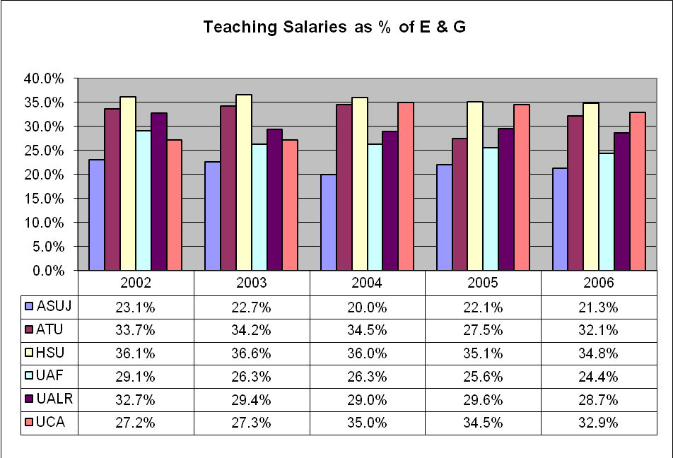

Illustration 22B
Spending on Teaching Salaries, Dept Operating Expenses & Research

SREB Institutions come from 16 states -- Alabama, Arkansas, Delaware, Florida, Georgia, Kentucky, Louisiana, Maryland, Mississippi, North Carolina, Oklahoma, South Carolina, Tennessee, Texas, Virginia, and West Virginia.
ADHE, 2008-09 Tuition & Mandatory Fee Summary Chart, Table 4A, http://www.adhe.edu/divisions/institutionalfinance/Pages/InstitutionalReporting.aspx
UCA FY 2008 Audited Financial Statements were not available as the report was being prepared.
UCA, Ark. Tech exceed caps on scholarships, JONESBORO SUN, November 12, 2007, p. A7.
SREB Fact Book 2007, p. 151.
This data comes from the Common Data Set available on the website for Institutional Research. This report excludes graduate teaching assistants and clinical faculty from its definition of part time faculty. Thus, the actual number of part time faculty would be higher if those were included
Discrepancy from 461 total reported in Illustration 2 is due to difference in data source; 461 was reported on Common Data Set prepared by Office of Institutional Research while 471 is from a report prepared by Dr. Howard for Academic Affairs and Research Council also based on OIR information. Overall trend is not likely to be changed significantly by this reporting difference.
SREB Fact Book 2007, p. 155.
SREB Fact Book 2007, p. 157.
SREB Fact Book 2007, p. 159.
This information is adapted from Tables 5.1 A, B, C, E,G,& J in the ADHE Fact Book 2007.

